Partnerships
- What double entry is necessary to record interest earned on partners' capital account balances?
DEBIT Partners' current accounts
CREDIT Appropriation account
DEBIT Appropriation account
CREDIT Partners' current accounts
DEBIT Appropriation account
CREDIT Bank
DEBIT Appropriation account
CREDIT Partners' capital accounts

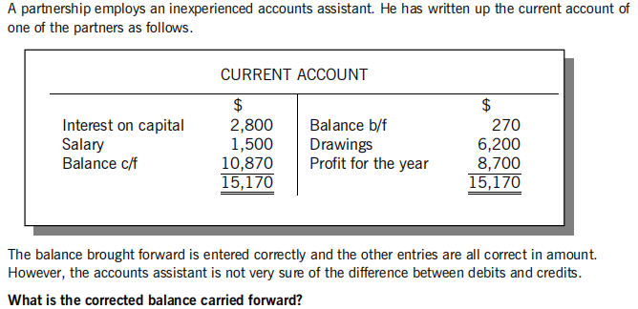

What is the corrected balance carried forward?
A debit balance of $1,530
A debit balance of $6,530
A credit balance of $7,070
A credit balance of $16,470

- A partner's private petrol bills have been treated as part of the partnership's motor vehicle expenses.

Which of the following entries is necessary to correct the error?

DEBIT Drawings account
CREDIT Motor vehicle expenses account
DEBIT Motor vehicles expenses account
CREDIT Drawings account
DEBIT Motor vehicles expenses account
CREDIT Capital account
DEBIT Capital account
CREDIT Motor vehicle expenses account

- What double entry is necessary to record interest payable on partners' drawings?
DEBIT Partners' drawings accounts
CREDIT Partners' current accounts
DEBIT Appropriation account
CREDIT Partners' drawings accounts
DEBIT Partners' drawings accounts
CREDIT Interest payable account
DEBIT Partners' current accounts
CREDIT Appropriation account

- What does a debit balance on a partner's current account indicate?
The firm owes the partner money
The partner owes the firm money
The partner's bank account is overdrawn
The firm has made a loss in recent years

- Ingrid and Sam are in partnership sharing profits and losses in the ratio 3:4. The statement of profit or
loss for the year to 31 May 20X6 reported a profit for the year of $30,709. Ingrid is entitled to a salary
of $14,000 per annum.
What was Sam's share of the profit for the year to 31 May 20X6?
$7,161
$9,548
$17,548
$25,548

- Alex and Kim are in partnership. In the year to 31 October 20X6, Alex's drawings were $18,000 and
the following entries were made in the partnership appropriation account for Alex:
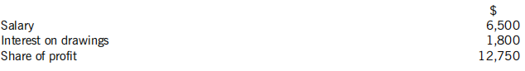
At 1 November 20X5, the balance on Alex's current account was $24,800 (credit).
What was the balance on Alex's current account at 31 October 20X6?
$ 24,250

- Alec and Carl are in partnership, sharing profits and losses in the ratio 3:2. The statement of profit or
loss for the year to 31 October 20X8 reported a profit for the year of $98,500.
Interest on capital has been calculated as:
Alec $7,900
Carl $5,100
Both capital and current accounts are maintained in the accounting records of the partnership. Neither
partner made any drawings in the year to 31 October 20X8.
What was the increase in the balance on Carl's current account in the year to 31 October 20X8?
$34,200
$39,300
$39,400
$49,700

- Bruce and Larry have been in a partnership for several years and share profits and losses equally. On
1 January 20X1, they are going to be joined by a new partner, Eddie. Bruce and Larry estimate that at
this date they have goodwill of $12,000. They decide that they will not maintain the goodwill in the
partnership's accounts. The new profit sharing ratio between Bruce, Larry and Eddie is 2:2:1.
What adjustments should be made in the partners' capital accounts when the goodwill is removed
from the accounts?
Debit the capital accounts $6,000 (Bruce) and $6,000 (Larry)
Credit the capital accounts $6,000 (Bruce) and $6,000 (Larry)
Debit the capital accounts $4,800 (Bruce), $4,800 (Larry) and $2,400 (Eddie)
Credit the capital accounts $4,800 (Bruce), $4,800 (Larry) and $2,400 (Eddie)

- David and Tony have been in partnership, sharing profit and losses in the ratio 3:2.
At 1 July 20X3, Jack was admitted to the partnership when the goodwill was valued at $50,000. The
partners drew up a new partnership agreement stating that profits would now be shared equally and that
goodwill would not be maintained in the accounts. On 1 July 20X3, the total value of the capital and
current balances of David and Tony was $360,000.
How much must Jack contribute to the partnership to ensure that his opening capital balance is nil?
$ 16,667

- Sarah and Tanya were equal partners in a business, each with capital of $120,000. It was agreed that Ursula should join the partnership, with all three partners sharing profits equally. For the purpose of admitting the new partner, the value of the goodwill of the business was agreed at $90,000, but goodwill would not be maintained in the accounts. Ursula introduced $80,000 in cash to the business.
What were the balances on the capital accounts of Sarah and Ursula after the admission of Ursula to
the partnership?
Sarah Ursula
$120,000 $80,000
$135,000 $50,000
- $150,000 $50,000
$165,000 $80,000

- Bruce and Lee are in partnership. The balances on their capital and current accounts at the start of the
financial year were as follows:
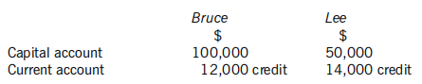
Lee is paid a salary of $40,000 per year. Both partners take interest on capital at 6% per year. The residual profits are shared between Bruce and Lee in the ratio 4:3. During the year just ended, the partnership profit was $199,500 and Bruce drew $7,500 each month from the business.
What were the balances on Bruce and Lee's current accounts at the end of the year?
Bruce Lee
$1,800 $107,500
$4,000 $121,500
$9,800 $118,500
- $14,000 $121,500

- Amber and Kieran are in partnership. Amber is entitled to a salary of $19,000 per annum according to the partnership agreement.
The profit for the year of the partnership for the year ended 31 May 20X5 was $108,255. The figures for interest on capital and interest on drawings for the year were as follows:
Amber Kieran
Interest on capital $10,200 $9,300
Interest on drawings $2,100 $3,300
What was the residual profit for the year to 31 May 20X5?
$103,355
$83,855
$75,155
$64,354

- Which of the following best describes a partnership?
Two people who run a business
A business arrangement between a number of people who share profit equally
A relationship that exists between persons carrying on a business in common with a view of profit
A business arrangement involving shareholders

- Which of the following items would NOT be included in a partnership agreement?
The profit sharing ratio
The maximum amount that any partner can loan to the business
Interest to be charged on partners' drawings
Salaries to be paid

- Partnership accounts show a capital account and a current account for each partner.
Are the following statements true or false?
True False
A wide range of items are recorded in the capital account
The current account normally remains constant from year to year

